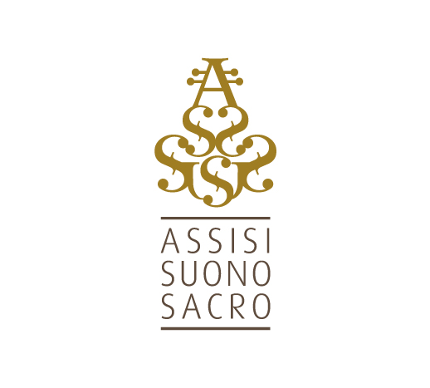**Assisi Suono Sacro | Academy 2020**

Assisi will come back to life with its master classes also next summer 2020. The courses will be scheduled in blocks of a week starting from 3-9 and from 10-16 August 2020.

The program includes both interpretation and composition courses. Central to a deep search of sound and music according to the principles of Poor Sound, of which **Assisi Suono Sacro** has been a spokesperson for years, and the construction of an enlightened musician capable of an innovative capacity for communication. In search of that sound that, freed from the trappings of fashion, is able to enter into deep contact with the human soul and as such to speak the language of the spirit, beyond cultures and religions.

The costs range from €. 370.00 for instrument master classes, €. 470.00 for those of composition. The workshops and seminars cost €. 120.00.

All fees are inclusive of registration to the Association.

Entries must be received without delay by June 15, 2020.

To participate in the courses it is necessary to register by downloading and signing the form on the website [www.assisisuonosacro.eu/accademia](http://www.assisisuonosacro.eu/accademia) and sending it by e-mail to [masterclassassisi@gmail.com](mailto:masterclassassisi@gmail.com) attaching the payment receipt.

The courses will be activated only and exclusively to achieve a minimum number of students per teacher.

If the course is not activated due to insufficient enrollment or due to force majeure by the Association or the teacher, the enrollment fee will be fully reimbursed to the students.